Chapter 4: Results and Evaluation

4.1 Introduction
This chapter reports the findings of the machine learning application to predicting hourly demand of urban bike-sharing. The primary experiment was based on the Seoul Bike Sharing Demand dataset as the main dataset, and the Washington D.C. Bike Sharing dataset was the parallel comparison dataset. This chapter aims at assessing the effectiveness of weather, seasonal, calendar and time-based predictors of bike rental demand.
The findings are given in phases. To describe significant demand trends in the Seoul data, first, the results of the exploratory data analysis are discussed. Second, the machine learning models are tested based on Mean Absolute Error, Root Mean Squared Error and R 2 score. Third, actual-versus-predicted plots, residual analysis and feature importance are used to analyse the best-performing model. Fourth, the results of cross-validation and time-series validation are discussed to determine the reliability of the models. Fifth, the results of the Washington D.C. parallel dataset are provided and compared with the Seoul dataset. Lastly, the chapter concludes by summarising the key findings and how the findings address the research objectives.

4.2 Dataset Preparation Results
The Seoul Bike Sharing Demand data was loaded and inspected successfully and then modelled. The data was 8,760 rows and 14 columns, which consisted of hourly bike rental data in a single year. The final modelling dataset was 8,760 records and 20 columns after preprocessing, categorical encoding and feature engineering, including the target variable and 19 predictor features. The target variable was Rented_Bike_Count and the input features were weather features, calendar features, seasonal features and engineered variables like Is_Weekend and Is_Peak_Hour.
The final feature matrix had 8,760 rows and 19 features, whereas the target array had 8,760 values. The data was divided into training and testing data with an 80/20 split. The training set had 7,008 records and the testing set had 1,752 records. The Seoul dataset did not have any missing values and no duplicated rows were observed. This implied that there was no imputation or duplicate-removal correction needed. The categorical variables like Seasons, Holiday and Functioning_Day were effectively coded into numerical columns and the dataset was appropriate to be used in regression modelling.
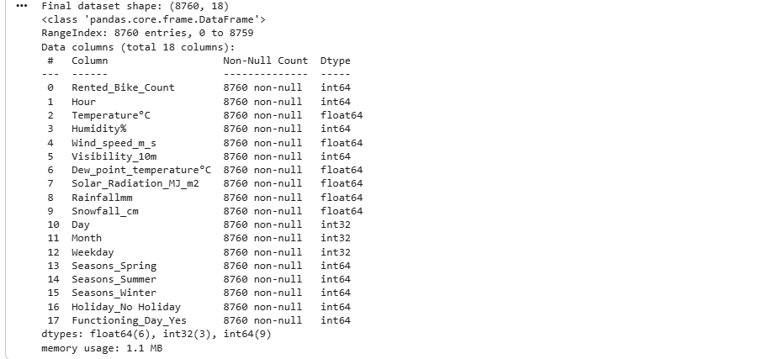
Table : Seoul Dataset Preparation Summary
Stage | Output
Original dataset shape | 8,760 rows × 14 columns
Final modelling dataset shape | 8,760 rows × 20 columns
Number of predictor features | 19
Target variable | Rented_Bike_Count
Training set | 7,008 rows
Testing set | 1,752 rows
Missing values | 0
Duplicate rows | 0

4.3 Exploratory Data Analysis Results

4.3.1 Distribution of Bike Rental Demand
The distribution of hourly rented bike count was positively skewed. The skewness was 1.153, indicating that the majority of the hours were low or moderate demand, and the number of hours with very high demand was less. This is practical in the case of bike-sharing systems since demand does not remain the same throughout the day. The demand is generally high during the commuting times and low during the late-night or bad-weather times.
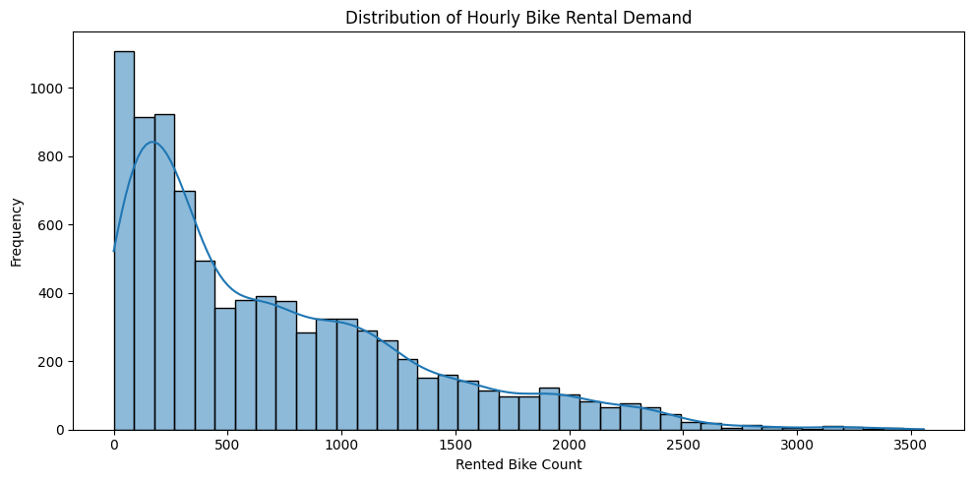
Figure : Distribution of Hourly Rented Bike Count

4.3.2 Hourly Demand Pattern
The hourly demand plot revealed a definite daily trend. The demand was low in the early morning hours, high in the morning commuting hours and peaked in the morning at around 8 AM. The peak average demand was at approximately 6 PM, which shows that there is high evening commuting behaviour. This confirmed that Hour and Is_Peak_Hour were important predictors for bike rental demand.
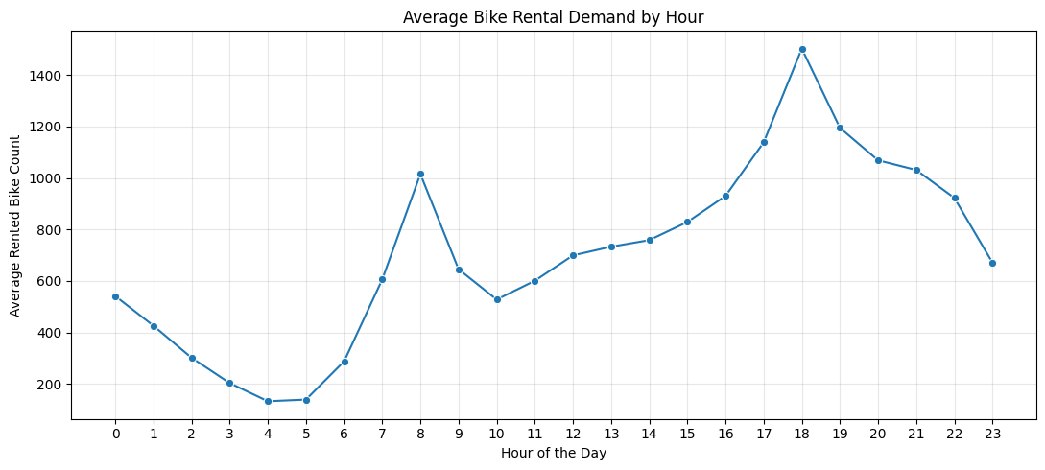
Figure : Average Bike Rental Demand by Hour

4.3.3 Seasonal Demand Pattern
The seasonal analysis revealed that there were significant variations in the average demand between seasons. The peak of bike rental demand was in summer, then autumn and spring, and the lowest demand was in winter. The mean number of rentals are:
Season | Average Rented Bike Count
Winter | 225.54
Spring | 730.03
Summer | 1034.07
Autumn | 819.60
These findings indicate that weather and seasonal factors have a strong impact on cycling behaviour. The demand was significantly lower in winter, which is likely because of cold weather, snow and decreased comfort in cycling.
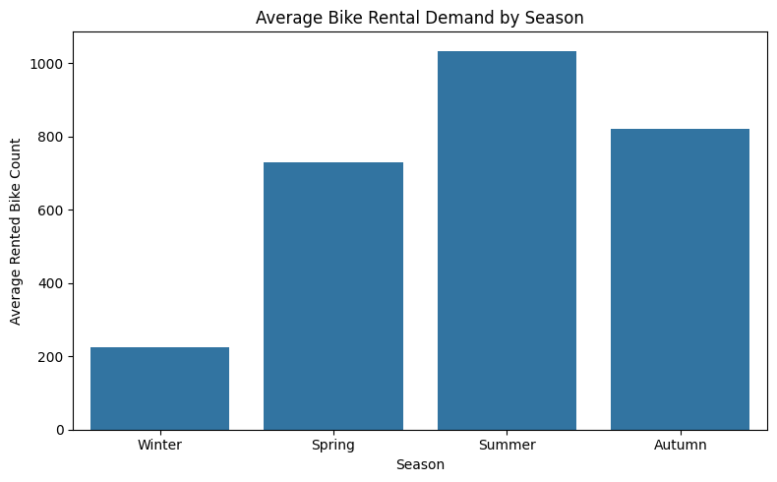
Figure : Average Bike Rental Demand by Season

4.3.4 Demand by Day of the Week
The day-of-week analysis indicated that there was moderate variation among the weekdays. Friday recorded the highest average demand at about 747.12 whereas Sunday recorded the lowest average demand at about 625.16. This implies that the demand of bike-sharing is affected by the weekday and weekend trends. The outcome justifies the addition of Weekday and Is_Weekend as model features.
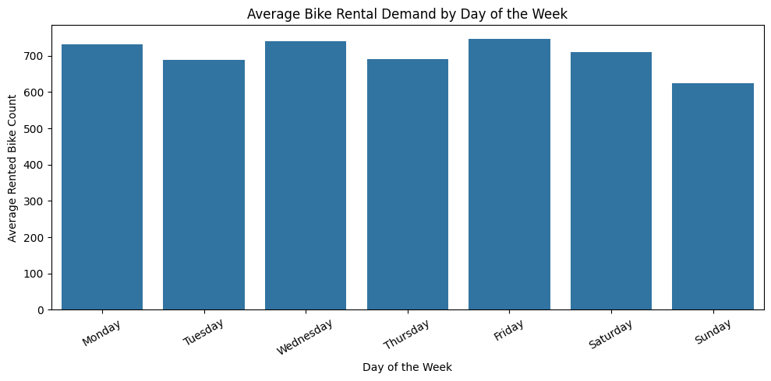
Figure : Average Bike Rental Demand by Day of the Week

4.3.5 Temperature and Bike Demand
The correlation between temperature and bike rental demand was moderate and positive (0.539). This shows that the demand of bikes tended to rise with rise in temperature. This trend is practically significant since warmer weather tends to provide more comfortable conditions to ride a bicycle.
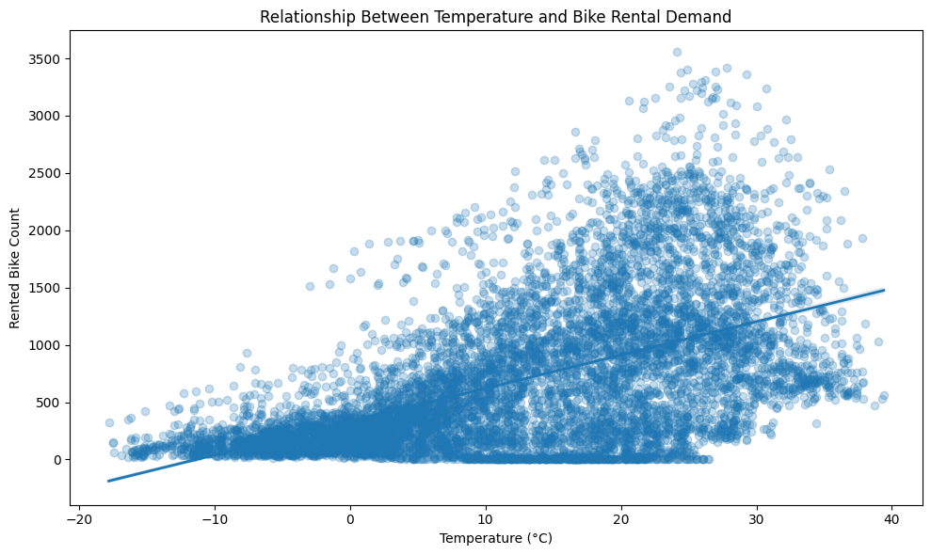
Figure : Relationship Between Temperature and Bike Rental Demand

4.3.6 Rainfall and Bike Demand
Rainfall had a strong negative effect on bike demand. Most records had no rain, while rainy conditions were less frequent. The rainfall category counts were:
Rainfall Category | Number of Records
No Rain | 8,232
Light Rain | 462
Moderate Rain | 53
Heavy Rain | 13
Average demand dropped sharply when rainfall occurred:
Rainfall Category | Average Rented Bike Count
No Rain | 739.31
Light Rain | 176.66
Moderate Rain | 66.21
Heavy Rain | 90.85
The results show that rain strongly discourages bike usage. However, heavy rain had only 13 observations, so its average demand should be interpreted carefully.
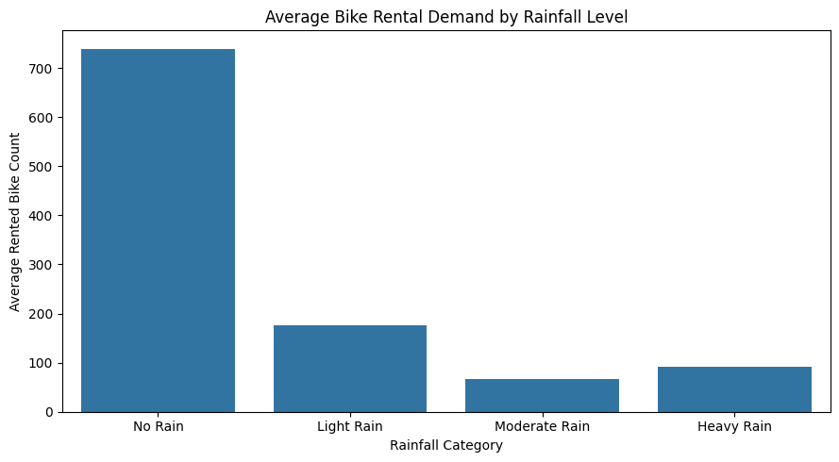
Figure : Average Bike Rental Demand by Rainfall Level

4.3.7 Correlation Heatmap and Feature Correlations
The correlation heatmap revealed that TemperatureC, Hour, Dew_point temperatureC and Solar Radiation MJ m2 had a positive relationship with bike rental demand. Humidity, Rainfallmm and Snowfall_cm were found to have negative relationships.
The strongest numerical correlations with the target variable were:
Feature | Correlation with Rented_Bike_Count
TemperatureC | 0.5386
Hour | 0.4103
Dew_point_temperatureC | 0.3798
Solar_Radiation_MJ_m2 | 0.2618
Visibility_10m | 0.1993
Month | 0.1335
Wind_speed_m_s | 0.1212
Weekday_Number | -0.0294
Rainfallmm | -0.1231
Snowfall_cm | -0.1418
Humidity | -0.1998
These results confirmed that weather and time-based variables were relevant to the prediction task.
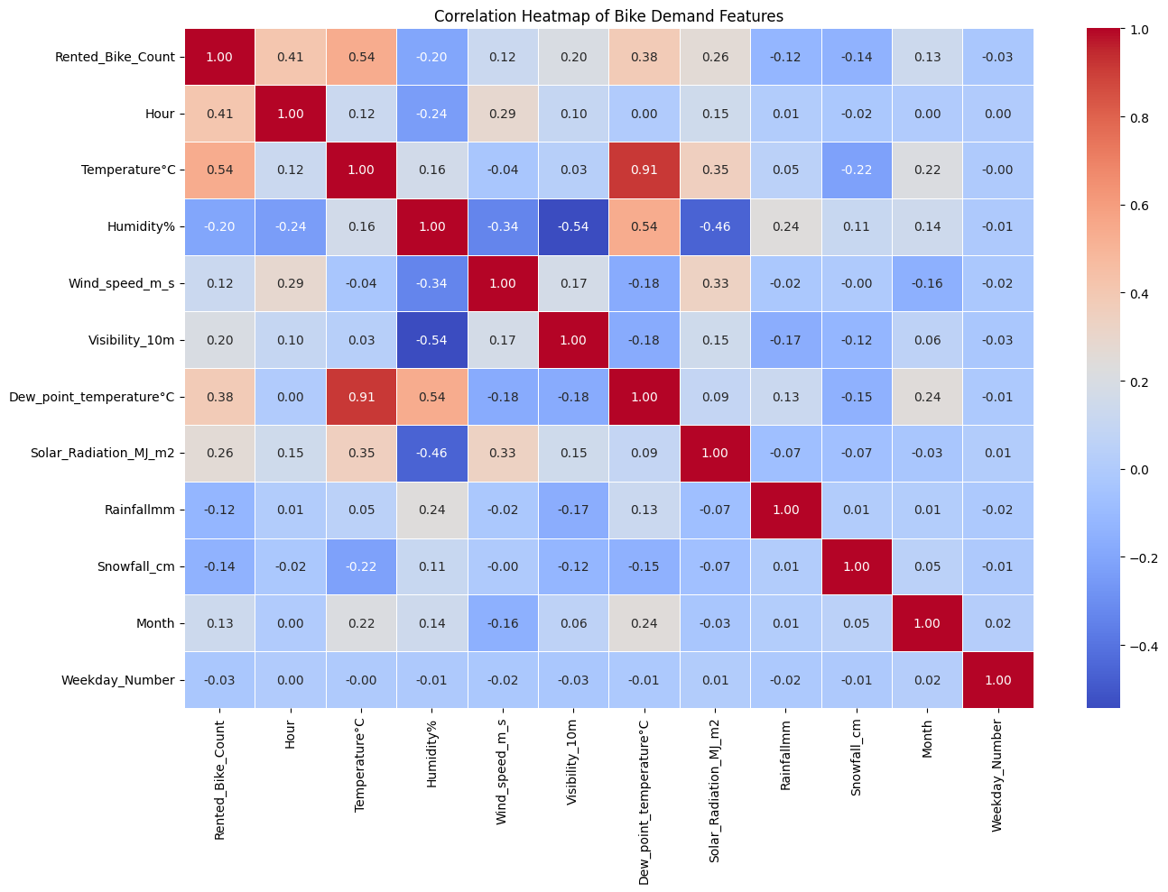
Figure : Correlation Heatmap of Bike Demand Features

4.3.8 Functioning Day Demand
The analysis of the functioning-day revealed that the average number of rentals was 0 when the bike-sharing system was not operational. The average number of rentals was 729.16 when the system was operating. This result shows that Functioning_Day_Yes is an important predictor. Nonetheless, since this variable directly describes zero-rental periods, another ablation test was subsequently conducted to make sure that the model was not over-reliant on this characteristic.
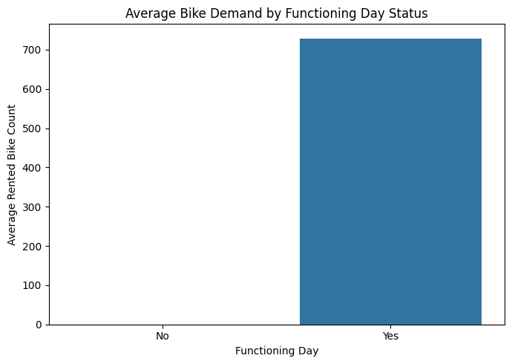
Figure : Average Bike Demand by Functioning Day Status

4.4 Seoul Model Performance Results
Four regression models were trained and evaluated on the Seoul dataset: Linear Regression, Random Forest, Gradient Boosting and XGBoost. The models were evaluated using MAE, RMSE and R² score.
Table : Seoul Test-Set Model Performance
Model | MAE | RMSE | R² Score
XGBoost | 94.535 | 161.006 | 0.938
Random Forest | 98.405 | 173.620 | 0.928
Gradient Boosting | 142.334 | 225.488 | 0.878
Linear Regression | 286.701 | 389.809 | 0.635
The results show that XGBoost was the best-performing model on the Seoul test set. It achieved the lowest RMSE of 161.006 and the highest R² score of 0.938. This means that XGBoost explained approximately 93.8% of the variation in hourly bike rental demand. Random Forest was the second-best model, with RMSE of 173.620 and R² of 0.928. Gradient Boosting performed moderately well, while Linear Regression had the weakest performance.
The stronger performance of XGBoost and Random Forest indicates that bike-sharing demand contains non-linear relationships and feature interactions that simple Linear Regression cannot capture effectively.
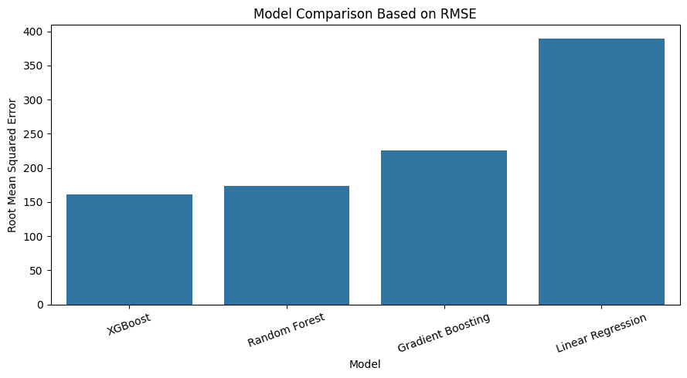
Figure : Seoul Model Comparison Based on RMSE
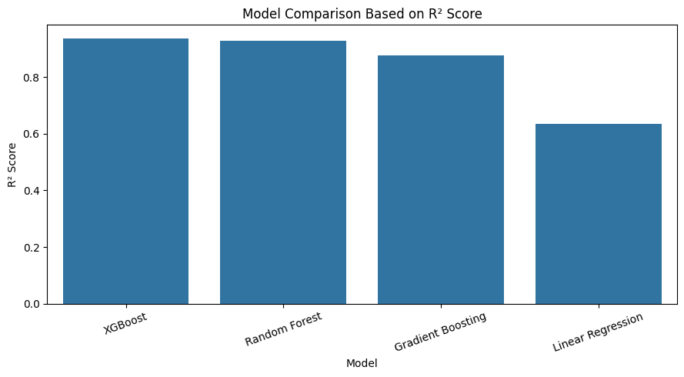
Figure : Seoul Model Comparison Based on R² Score

4.5 Actual vs Predicted Results for Best Seoul Model
XGBoost was selected as the best model based on the lowest RMSE. The actual-versus-predicted plot showed that most predicted values were close to the diagonal reference line. This means that the model predicted hourly bike rental demand with good accuracy.
The model performed especially well for low and medium demand values. However, some larger errors were visible at very high demand levels. This is expected because high-demand periods are less frequent and more difficult to predict precisely.
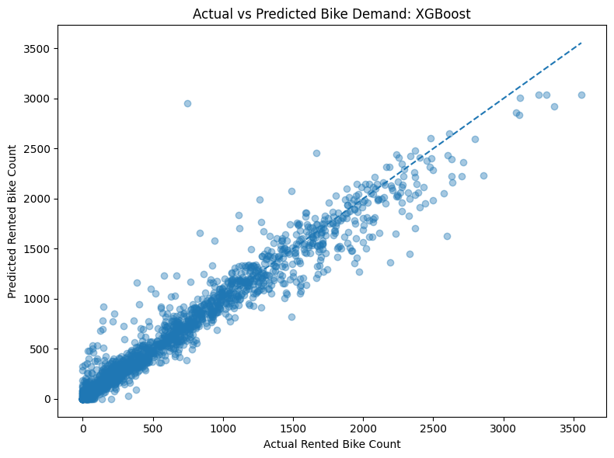
Figure : Actual vs Predicted Bike Demand for XGBoost on Seoul Dataset

4.6 Residual Analysis
Residual analysis was performed for the XGBoost model. The residuals were calculated as the difference between actual and predicted values. The residual summary was:
Statistic | Residual Value
Count | 1,752
Mean | 1.512
Standard deviation | 161.045
Minimum | -2206.165
25% | -55.598
Median | 0.000
75% | 50.046
Maximum | 968.310
The mean residual was close to zero, which indicates that the model did not show a strong overall bias toward overprediction or underprediction. Most residuals were concentrated near zero, suggesting that prediction errors were generally small. However, there were some extreme residuals, particularly during high-demand periods. This indicates that the model may struggle with unusual or very high rental demand events.
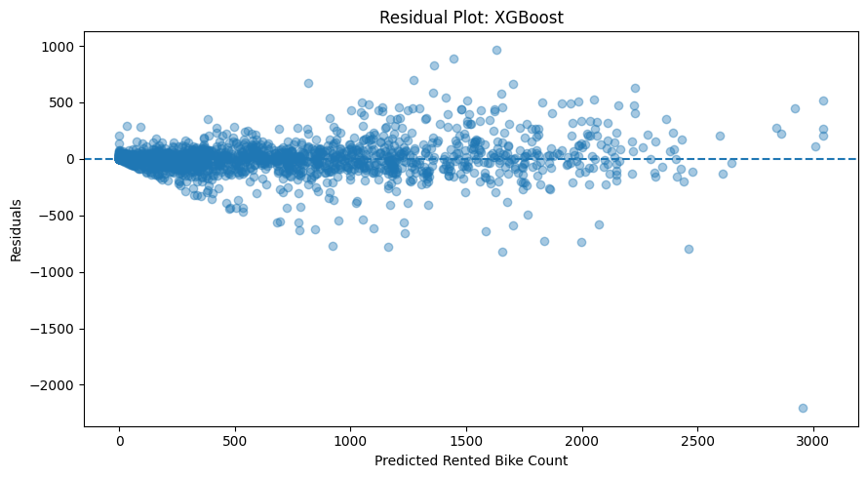
Figure : Residual Plot for XGBoost on Seoul Dataset

4.7 Seoul Cross-Validation Results
4.7.1 K-Fold Cross-Validation
To test model stability, 5-fold cross-validation was applied to the Seoul dataset.
Table : Seoul K-Fold Cross-Validation Results
Model | CV_MAE | CV_RMSE | CV_R²
XGBoost | 96.676 | 157.074 | 0.941
Random Forest | 94.201 | 163.874 | 0.935
Gradient Boosting | 141.889 | 216.229 | 0.888
Linear Regression | 304.391 | 403.634 | 0.608
XGBoost again achieved the lowest RMSE and highest R² score under K-Fold cross-validation. This confirms that the XGBoost result was not dependent only on a single train-test split. Random Forest remained close, but XGBoost had slightly stronger overall performance.
4.7.2 Time-Series Cross-Validation
Time-series cross-validation was also applied because the dataset is hourly and time-related.
Table : Seoul Time-Series Cross-Validation Results
Model | Time_CV_MAE | Time_CV_RMSE | Time_CV_R²
XGBoost | 240.228 | 345.756 | 0.625
Random Forest | 252.032 | 368.755 | 0.582
Gradient Boosting | 268.634 | 373.170 | 0.580
Linear Regression | 354.443 | 482.968 | 0.405
The time-series validation results were weaker than the random train-test and K-Fold results. This is expected because time-series validation is stricter and more realistic for future prediction. Even under this stricter validation method, XGBoost remained the strongest model.

4.8 Feature Importance Results for Seoul
Feature importance was extracted from the XGBoost model to understand which variables most influenced prediction.
Table : Top Seoul Feature Importances from XGBoost
Rank | Feature | Importance
1 | Seasons_Winter | 0.268144
2 | Functioning_Day_Yes | 0.184251
3 | TemperatureC | 0.088241
4 | Hour | 0.086141
5 | Rainfallmm | 0.064883
6 | Is_Peak_Hour | 0.051121
7 | Humidity | 0.047830
8 | Is_Weekend | 0.045189
9 | Solar_Radiation_MJ_m2 | 0.040122
10 | Month | 0.030941
11 | Seasons_Summer | 0.022624
12 | Weekday | 0.020697
13 | Dew_point_temperatureC | 0.018105
14 | Holiday_No_Holiday | 0.013550
15 | Seasons_Spring | 0.004071
The most important feature was Seasons_Winter, indicating that winter strongly affects bike demand. Functioning_Day_Yes was also highly important because non-functioning days produced zero rentals. Weather variables such as temperature, rainfall, humidity and solar radiation were also important. Time-based variables such as hour, peak-hour status, weekend status and month also contributed to the predictions.
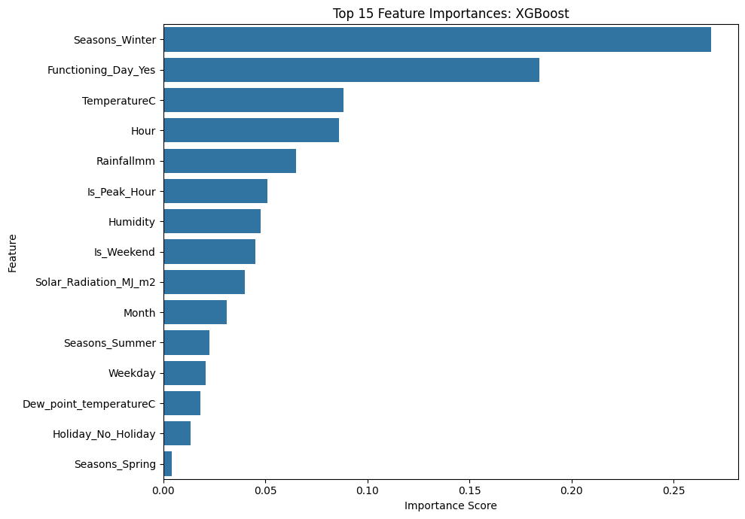
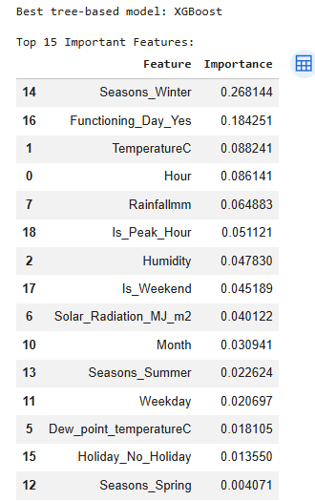
Figure : Top 15 Feature Importances for XGBoost on Seoul Dataset

4.9 Functioning Day Ablation Test
An ablation test was performed to check whether the model depended too heavily on the Functioning_Day_Yes feature. The XGBoost model was evaluated with and without this variable.
Table : Functioning Day Ablation Test Results
Model Version | MAE | RMSE | R² Score
XGBoost With Functioning Day | 94.535 | 161.006 | 0.938
XGBoost Without Functioning Day | 115.354 | 198.883 | 0.905
Removing Functioning_Day_Yes reduced model performance, increasing RMSE from 161.006 to 198.883 and reducing R² from 0.938 to 0.905. However, the model still performed well without the feature. This means that Functioning_Day_Yes improves prediction accuracy, but the model is not entirely dependent on it.
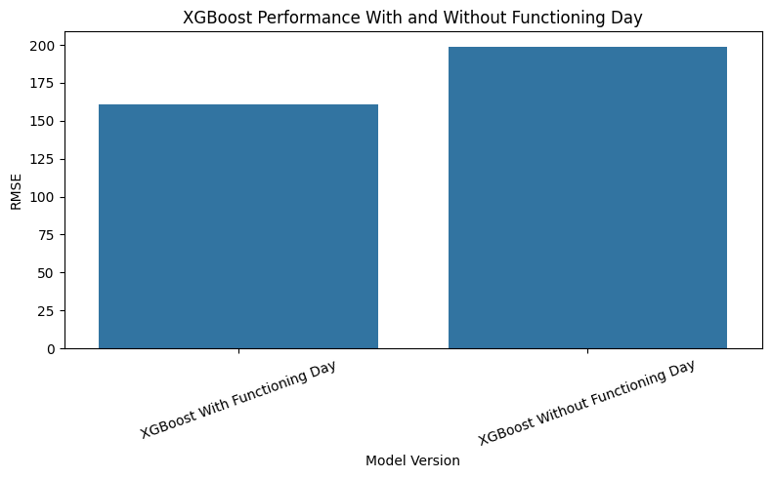
Figure : XGBoost Performance With and Without Functioning Day Feature

4.10 Washington D.C. Parallel Dataset Results
The Washington D.C. Bike Sharing dataset was used as a parallel study. The original dataset contained 17,379 rows and 17 columns. After removing leakage columns, feature engineering and encoding, the final modelling dataset contained 17,379 rows and 22 columns, including 21 predictor features and the target variable.
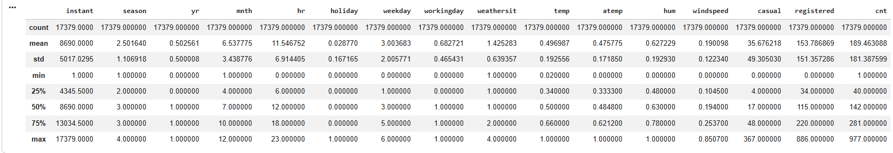
The dataset was split into training and testing sets. The training set contained 13,903 records, and the test set contained 3,476 records.
Table : Washington D.C. Test-Set Model Performance
Model | MAE | RMSE | R² Score
XGBoost | 25.717 | 40.549 | 0.948
Random Forest | 24.118 | 41.019 | 0.947
Gradient Boosting | 38.174 | 56.237 | 0.900
Linear Regression | 83.838 | 114.400 | 0.587
XGBoost achieved the best RMSE and R² score on the Washington D.C. test set, although Random Forest was extremely close. The results show that the same modelling workflow performed well on a second bike-sharing dataset.
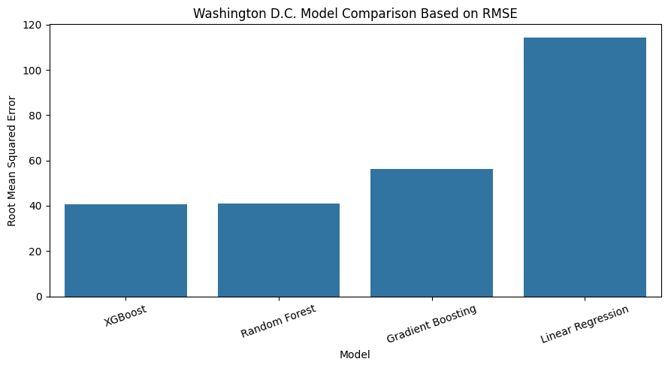
Figure : Washington D.C. Model Comparison Based on RMSE

4.11 Washington D.C. Cross-Validation Results
Table : Washington D.C. K-Fold Cross-Validation Results
Model | CV_MAE | CV_RMSE | CV_R²
Random Forest | 24.583 | 41.179 | 0.948
XGBoost | 26.621 | 41.699 | 0.947
Gradient Boosting | 41.136 | 59.953 | 0.891
Linear Regression | 89.000 | 118.792 | 0.571
Under K-Fold cross-validation, Random Forest slightly outperformed XGBoost. However, both models achieved very similar results, showing that tree-based ensemble methods were consistently strong.
Table : Washington D.C. Time-Series Cross-Validation Results
Model | Time_CV_MAE | Time_CV_RMSE | Time_CV_R²
XGBoost | 51.766 | 78.699 | 0.800
Random Forest | 55.133 | 85.752 | 0.761
Gradient Boosting | 65.150 | 94.241 | 0.720
Linear Regression | 100.463 | 135.172 | 0.441
In time-series validation, XGBoost again performed best. This shows that XGBoost generalised better when the chronological structure of the data was considered.

4.12 Washington D.C. Feature Importance and Prediction Plot
The Washington D.C. feature-importance analysis showed that the most important variables were Is_Peak_Hour, Hour, Year, Working_Day, Is_Weekend, Year_From_Date, Feeling_Temperature_Normalized, Season_4, Temperature_Normalized, and Weather_Situation_3.
This result is consistent with the Seoul findings because both datasets showed the importance of time-based, calendar-based and weather-based features. In Washington D.C., peak-hour status was the most important feature, suggesting that commuting patterns strongly influenced rental demand.
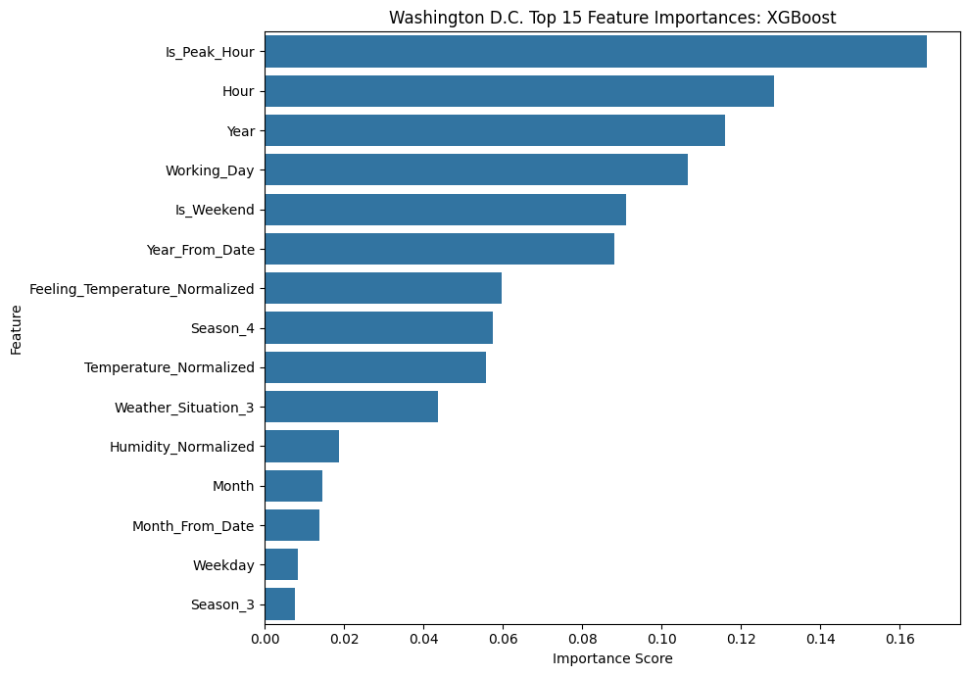
Figure : Washington D.C. Top 15 Feature Importances for XGBoost
The actual-versus-predicted plot for Washington D.C. showed that most points were close to the diagonal reference line. This confirmed that XGBoost predicted Washington D.C. rental demand accurately.
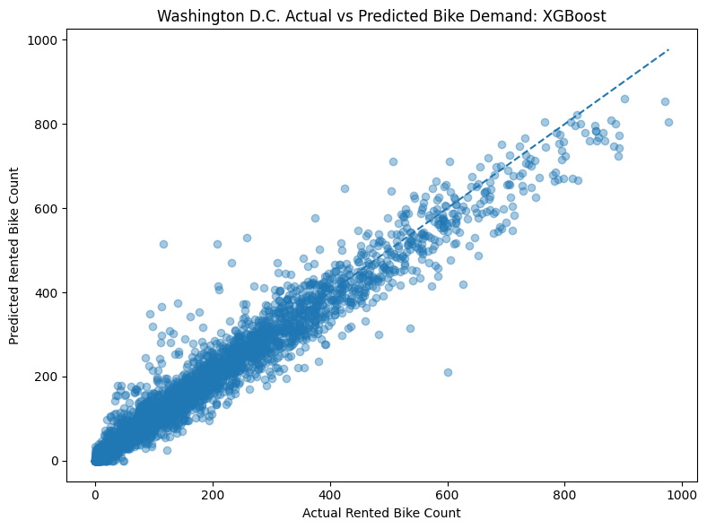
Figure : Washington D.C. Actual vs Predicted Bike Demand for XGBoost

4.13 Seoul and Washington D.C. Comparative Results
A combined comparison was created to compare model performance across both datasets.
Table : Combined Test Performance Results
Dataset | Model | MAE | RMSE | R² Score
Seoul | XGBoost | 94.535 | 161.006 | 0.938
Seoul | Random Forest | 98.405 | 173.620 | 0.928
Seoul | Gradient Boosting | 142.334 | 225.488 | 0.878
Seoul | Linear Regression | 286.701 | 389.809 | 0.635
Washington D.C. | XGBoost | 25.717 | 40.549 | 0.948
Washington D.C. | Random Forest | 24.118 | 41.019 | 0.947
Washington D.C. | Gradient Boosting | 38.174 | 56.237 | 0.900
Washington D.C. | Linear Regression | 83.838 | 114.400 | 0.587
XGBoost was the best test-set model on both datasets. However, RMSE values should not be directly compared between Seoul and Washington D.C. because the datasets have different target scales. Therefore, R² is a better high-level comparison measure. Based on R², both datasets showed strong performance for XGBoost and Random Forest.
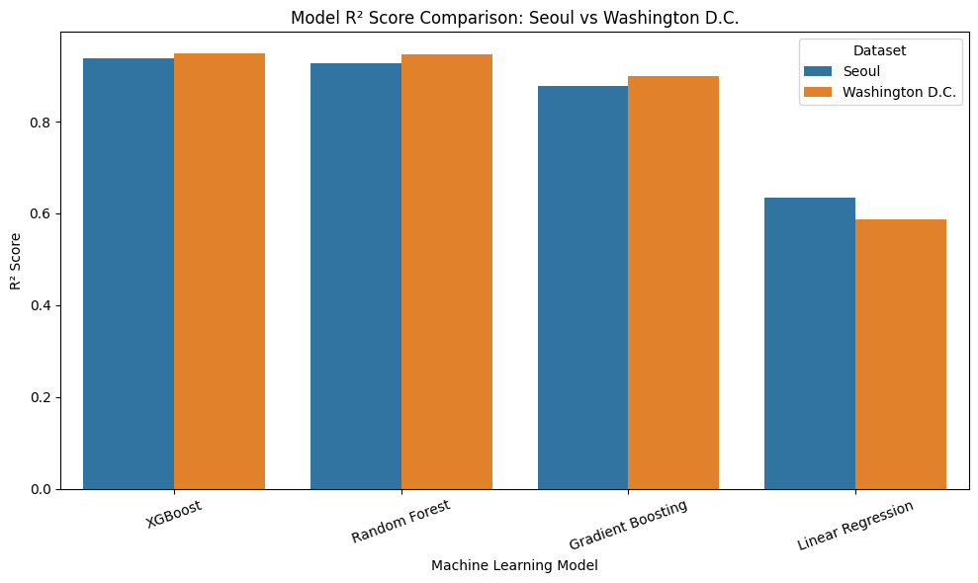
Figure : Model R² Score Comparison: Seoul vs Washington D.C.

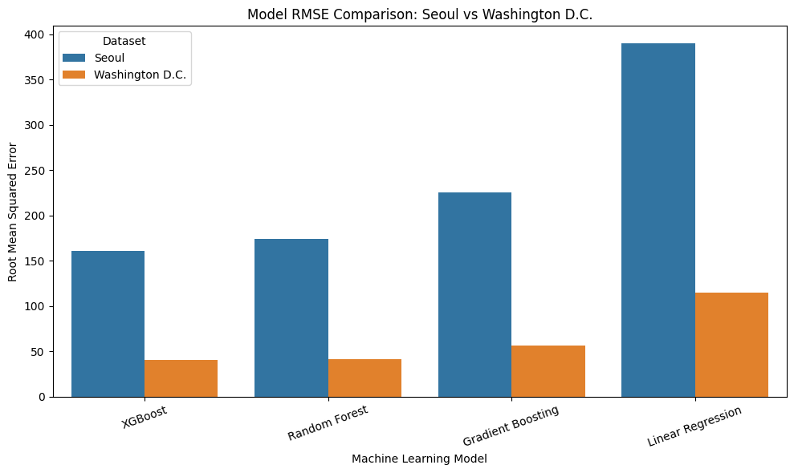
Figure : Model RMSE Comparison: Seoul vs Washington D.C.

4.14 Final Dashboard Interpretation
The final dashboard summarised four major comparisons: test R², test RMSE, K-Fold R² and best-model R² comparison. The dashboard clearly showed that XGBoost and Random Forest were the strongest models overall. Linear Regression was consistently weaker across both datasets, confirming that bike-sharing demand contains non-linear patterns that require more flexible models.
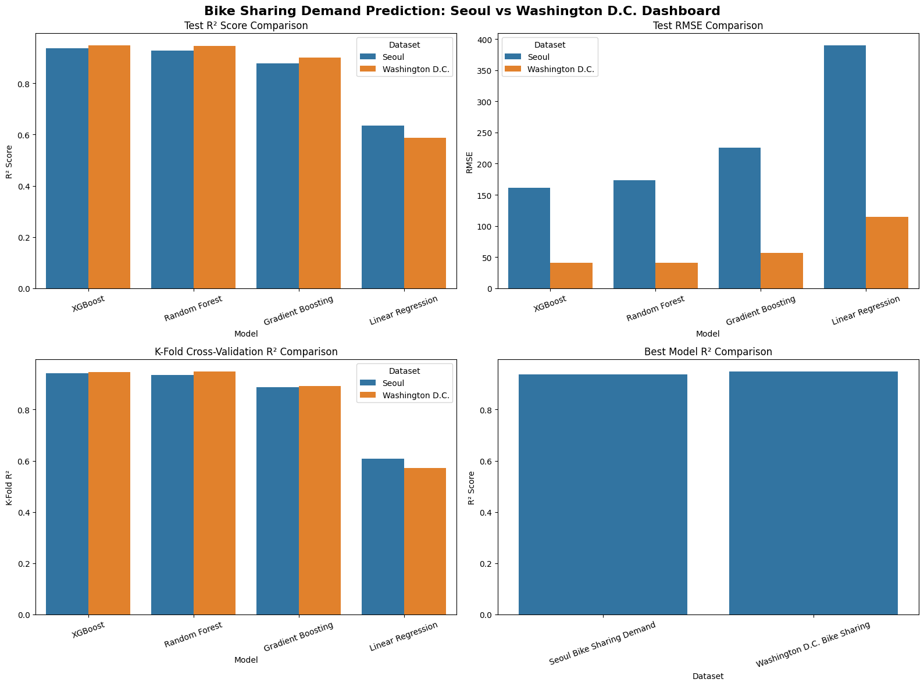
Figure : Final Seoul vs Washington D.C. Bike Sharing Demand Prediction Dashboard
The dashboard is useful because it provides a single visual overview of the complete modelling study. It connects the Seoul main study with the Washington D.C. parallel dataset analysis and supports the conclusion that ensemble models are more suitable than Linear Regression for bike-sharing demand prediction.

4.15 Summary of Findings
The results show that bike-sharing demand can be predicted effectively using weather, seasonal, calendar and time-based features. The Seoul dataset analysis showed clear demand patterns across hour, season, temperature, rainfall and functioning-day status. The strongest demand was observed during commuting hours and summer, while demand dropped during winter and rainy conditions.
Among the four models, XGBoost achieved the best Seoul test-set performance with MAE = 94.535, RMSE = 161.006 and R² = 0.938. Random Forest was the second-best model, while Linear Regression performed the weakest. Cross-validation confirmed that XGBoost remained stable and reliable, although time-series validation showed lower scores because it is a stricter evaluation method.
Feature importance showed that Seasons_Winter, Functioning_Day_Yes, TemperatureC, Hour, Rainfallmm and Is_Peak_Hour were among the most important predictors. The ablation test confirmed that Functioning_Day_Yes improved performance but was not the only reason for good prediction accuracy.
The Washington D.C. parallel dataset strengthened the findings. XGBoost again achieved the best test-set result with MAE = 25.717, RMSE = 40.549 and R² = 0.948. Random Forest was very close and slightly better under K-Fold validation. The combined results showed that tree-based ensemble models performed strongly across both datasets.
Overall, the results successfully meet the dissertation objectives. The project developed and evaluated a reproducible machine learning framework, compared multiple regression models, identified the best-performing model, interpreted important features and demonstrated that the workflow can be applied to another bike-sharing dataset for comparative analysis.

